**Database searching – Web of Science Core Collection**

The search process:

* Identify your key concepts
* For each key concept think of alternatives (e.g. synonyms, broader, narrower terms)
* Construct search strategy
* Run search and see if results are relevant
* Adapt search strategy to optimise results
* Save results (to reference management software?)

**1 – Searching**

**Recommended:** Add search fields so there is one box for each key concept

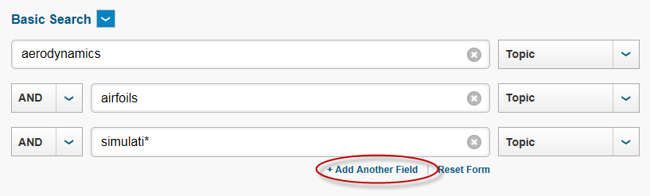

**Common functions/operators:**

|  |  |
| --- | --- |
| **Function/Operator** | **Example** |
| none | e.g. **finite element** – finds items containing both the words finite and element (includes singular/plural e.g. tooth/teeth, US/UK spelling variations) (assumes AND operator between words) |
| Lemmatization is switched on by default | System automatically searches for variants of search term (singular/plural, US/UK spelling variations). E.g. **tooth** finds items containing the words tooth or teeth. To search for exact term enclose in quotes e.g. “teeth” |
| **AND** operator | e.g. **finite AND element** – finds items containing both the words finite and element (includes singular/plural e.g. tooth/teeth, US/UK spelling variations) |
| **OR** operator | e.g. **recycling OR recovery** - finds items containing any of the following: the word recycling, the word recovery or both words (includes singular/plural e.g. tooth/teeth, US/UK spelling variations). This expands search |
| **NOT** operator | e.g. **cats NOT dogs** - finds items containing the word cats but not the word dogs (includes singular/plural e.g. tooth/teeth, US/UK spelling variations). Use with care |
| **NEAR/n** (n is number) proximity operator | e.g. **finite near/5 element** – finds items where there are up to 5 words between the words finite and element (and their variants) (in any order). Can be used with truncated words/ exact phrases. This narrows down search |
| * truncation character | e.g. **load\*** - finds items containing any word beginning with load (load, loading, loaded etc) |
| “ phrase searching | e.g**. “finite element”** or **“finite-element”** finds the phrases: finite element or finite-element. This narrows down search |
| Limit by title | Select Title from drop down menu next to search box. This can narrow down search |
| Refine panel | Left hand side. Can be used to narrow down search |
| Search history | Link at top right hand side. Edit previous searches (in expert mode only), save searches/create alerts |

**2 – Looking at results/altering search strategy**

* **Sort results –**change the order in which results are displayed e.g. by relevance, by date
* **Scan through some titles**– helps you determine if your search strategy is effective/needs altering (i.e. are you finding a high percentage of relevant or irrelevant items?)
* **Read abstracts** - click on item title. Use the abstract (summary) to help decide whether a paper is worth reading –search terms used are higlighted. You may also identify more search terms you may wish to use
* **Alter search strategy** you may need to revise your search strategy (too many/too few results, need to widen/narrow search)
* **Access full text** **(journal articles)** – click on the **SFX/View it** link (tries to get you to the full text if we have a subscription)
* **Select useful records** – tick box at side of record. These can be saved for later use e.g. details can be exported to reference management software such as Refworks, EndNote

**3 – Saving searches or results/Creating alerts**

Once you register for a personal account (Sign in link top right hand side) you can do the following:

* **Save searches** - you can then come back at a later date and rerun your saved search. From Search History
* **Create alerts** – you can receive regular emails telling you about new items added to the database matching your search strategy. Create Alert link left hand panel of results/from Search History
* **Journal alerts** – you can receive regular emails telling you about contents of new issues of selected journal titles

**4 – Exporting reference details to reference management software (e.g. RefWorks, EndNote)**

* Select items by ticking boxes at side of records
* Go to drop down menu at top of results list and select where you wish to save to e.g. Save to RefWorks